Test Case: tc001_SPX_Dev5_Crear_Requisicion_Spot_Tipo_Cobro_CC
Step 1 - Enter username and password and click to button Enter : Credentials Entered
Image file-name: QC_Testing-tc001_SPX_Dev5_Crear_Requisicion_Spot_Tipo_Cobro_CC-1790177205270

Step 2 - Select to UEN and Access to Spot Buy Requisitions : UEN Correctly selected and Correct access
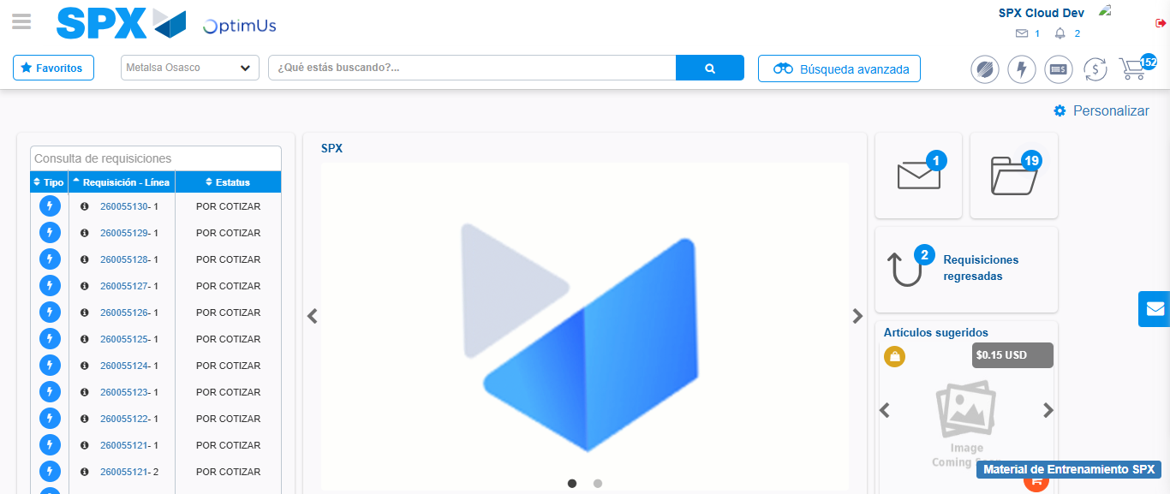Image file-name: QC_Testing-tc001_SPX_Dev5_Crear_Requisicion_Spot_Tipo_Cobro_CC-1790177228920

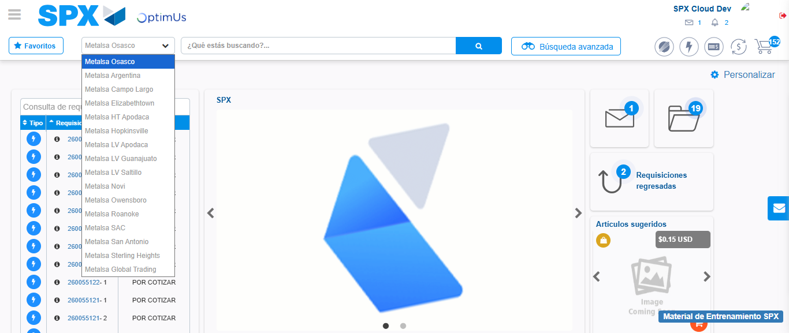Image file-name: QC_Testing-tc001_SPX_Dev5_Crear_Requisicion_Spot_Tipo_Cobro_CC-1790177229687

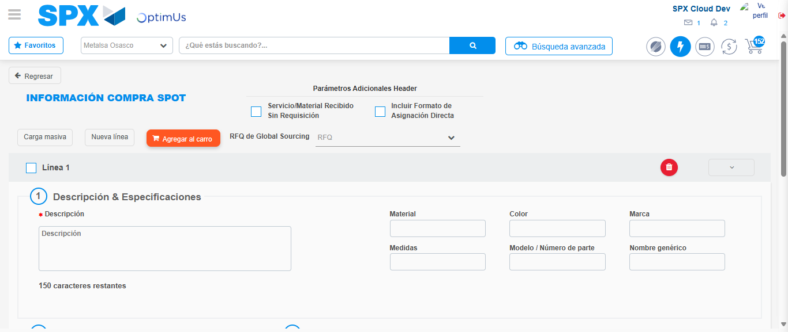Image file-name: QC_Testing-tc001_SPX_Dev5_Crear_Requisicion_Spot_Tipo_Cobro_CC-1790177234045

Step 3 - Data Capture Spot Buy Requisition : Data captured correctly
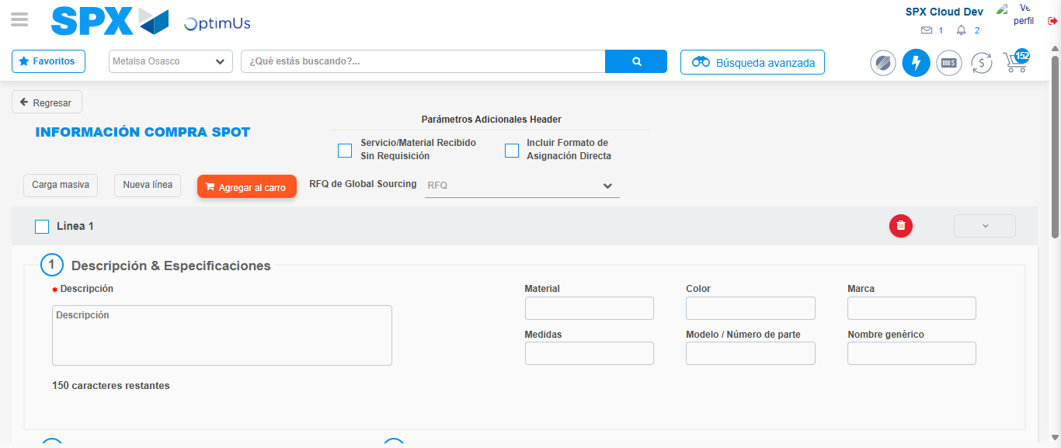Image file-name: QC_Testing-tc001_SPX_Dev5_Crear_Requisicion_Spot_Tipo_Cobro_CC-1790177234315

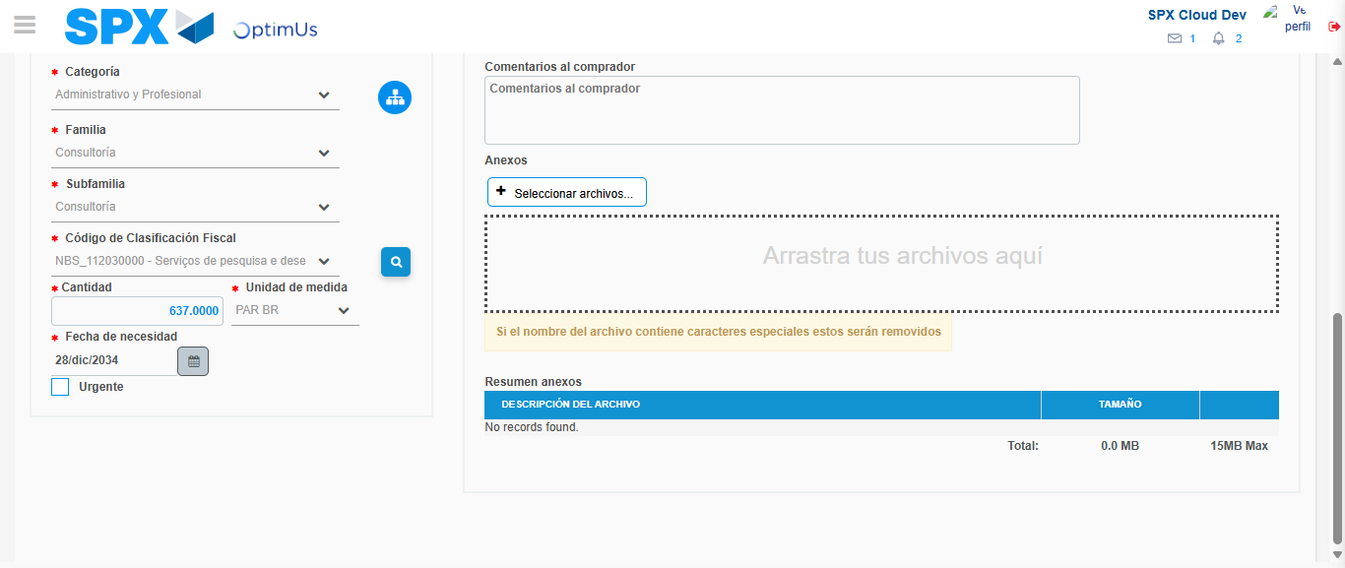Image file-name: QC_Testing-tc001_SPX_Dev5_Crear_Requisicion_Spot_Tipo_Cobro_CC-1790177275233

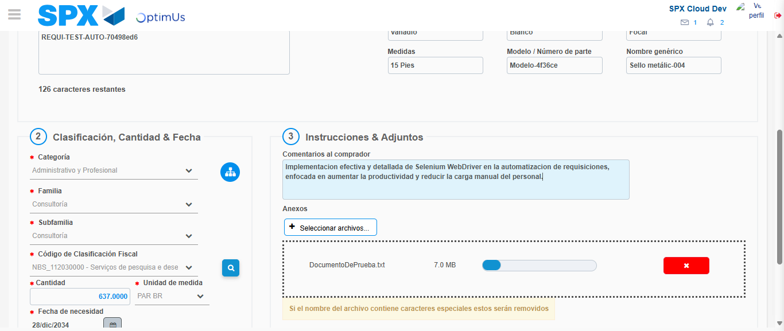Image file-name: QC_Testing-tc001_SPX_Dev5_Crear_Requisicion_Spot_Tipo_Cobro_CC-1790177276313

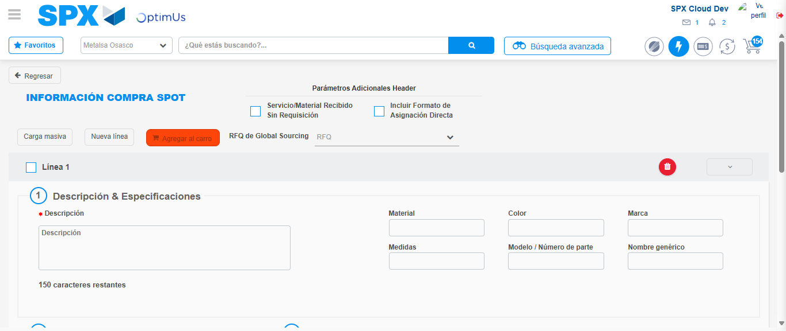Image file-name: QC_Testing-tc001_SPX_Dev5_Crear_Requisicion_Spot_Tipo_Cobro_CC-1790177279056

Step 7 - Return to Main Page SPX : Return to Main Page SPX
Image file-name: QC_Testing-tc001_SPX_Dev5_Crear_Requisicion_Spot_Tipo_Cobro_CC-1790177228920

Image file-name: QC_Testing-tc001_SPX_Dev5_Crear_Requisicion_Spot_Tipo_Cobro_CC-1790177229687

Image file-name: QC_Testing-tc001_SPX_Dev5_Crear_Requisicion_Spot_Tipo_Cobro_CC-1790177234045

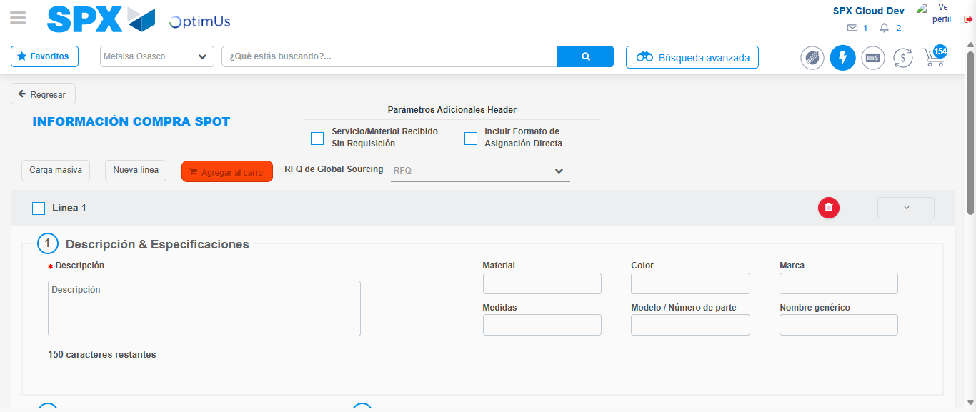Image file-name: QC_Testing-tc001_SPX_Dev5_Crear_Requisicion_Spot_Tipo_Cobro_CC-1790177281411

Image file-name: QC_Testing-tc001_SPX_Dev5_Crear_Requisicion_Spot_Tipo_Cobro_CC-1790177281693

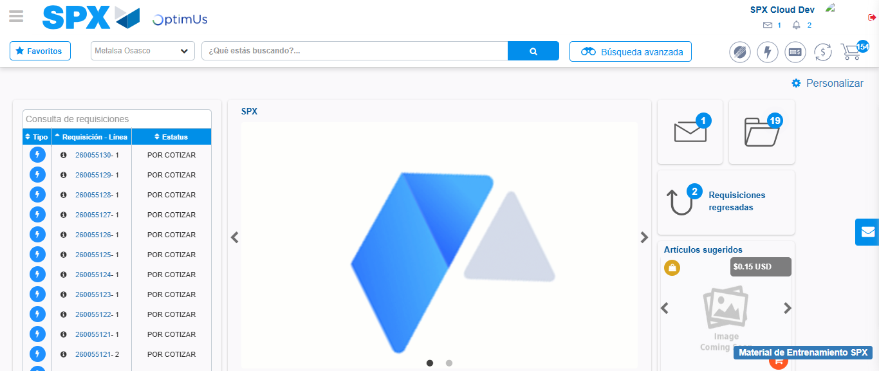Image file-name: QC_Testing-tc001_SPX_Dev5_Crear_Requisicion_Spot_Tipo_Cobro_CC-1790177303290

Step 8 - Log Out : Log Out SPX
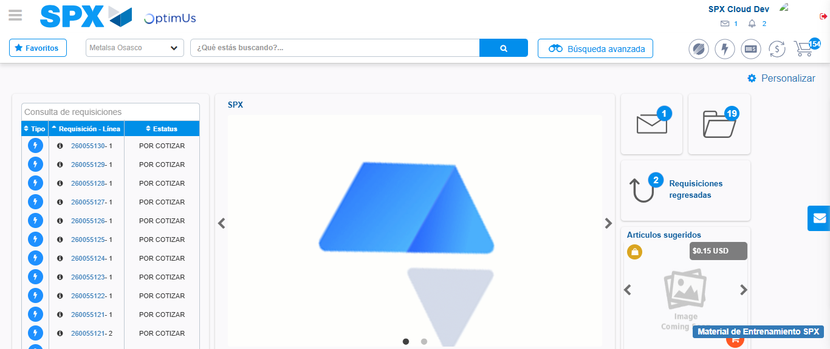Image file-name: QC_Testing-tc001_SPX_Dev5_Crear_Requisicion_Spot_Tipo_Cobro_CC-1790177303610

